**ADZ STRUCTURE**

**Main Menu**

Main menu should consist of the following below

**Single player**

**Player vs computer:** This game mode follows the rule of choice and turn.

(Player vs CPU uses a single 1v1 playing deck).

**Dual play:** This consists of a two-player game where each player battles against each other.

(Dual play uses a single 1v1 playing deck)

**Single/Dual play**

**Multiplayer**

**Tag team:** This consists of a four-player game where two players teaming up against the opposing two players. This game mode follows the rule of choice and turn.

(Tag team uses a multi 4 player deck)

**Royal rumble:** This consists of a four-player game where all players can attack any of the player without following a specific order, however this game mode still follows the rule of choice and turn.

(Royal rumble uses a multi 4 player deck)

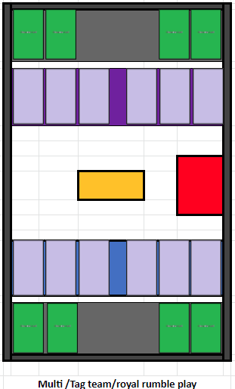**

**Multiplayer/Tag team/ Royal rumble playing deck design**

**Cards**

The cards may follow the basic rules of choice. There are 5 major types of cards in game:

1. Character cards
2. Attack card
3. Defence card
4. Support card
5. Special card

**Attack card:** All attack cards follow the rule of choice based on the player or opponent defending the attack card for e.g. block attack? Yes/No

**Defence cards**: There are three types of defence cards. Some defence cards may not follow the rule of choice.

* Contact and projectile defence; This type of card follows the rule of choice because the defence card is also acting as an attack card after blocking the attack, for an example I can use a contact defence or projectile card to block an attack card whilst dealing 500 damage then the attacker then has a choice to choose whether he will accept that 500 damage or block it. E.g. block damage? Yes/no
* Pure defence: Pure defence just avoids the attack without attacking the attacker so there is no need for the choice rule for this type of defence card.

**Support card:** All support cards follow the rule of choice based on the player or opponent allowing the card to play for E.g. Stop support? Yes/No. since support cards are not directly attacking a player they can only be blocked by a Special defence card.

**Special card:** All special cards follow the rule of choice based on the player or opponent defending a special attack or defence card for e.g. block attack? Yes/No. Some special cards can be used as both attack and defence cards.

**Character cards**

Character cards are split into two:

* Main character cards
* Support characters cards

Main character card

The main character cards consist of the character life, attack, and defence point. The main character cards are available to free to play players. They have an unlimited basic attack and a fixed character defence point. The main character has two secret card slots.

**Single/dual play Multiplayer/Tag team/ deck design**

* The main character card is the green slot located in the middle for single/dual play deck design
* The main character card is the green slot located in the corner for Multiplayer deck design

| Main Character Cards | Attack | Defence | Hp |
| --- | --- | --- | --- |
| Free character cards | 300 | 600 | 11000 |
| Uncommon character cards | 500 | 1000 | 13000 |
| Rare character cards | 700 | 1400 | 15000 |
| Legendary character cards | 900 | 1800 | 17000 |

Character card menu will be split into 4 categories that can be selected by players

* Free character cards are available to everyone.
* Uncommon, rare and legendary character card only accessible to NFT holders

**Support character cards**

Support character cards acts as a buff to the main character cards, they add extra points to the main characters' attack defence and Hp if they are in the game. Support characters are not available to free to play players. The support character has one secret card slot.

**Single/dual play Multiplayer/Tag team/ deck design**

* The support character card is the green slot located at the sides of the main character slot for single/dual play deck design
* The support character card is the green slot located at the outer corner for Multiplayer deck design

| Support Character Cards | Attack | Defence | Hp |
| --- | --- | --- | --- |
| Uncommon character cards | +50 | +100 | +300 |
| Rare character cards | +100 | +200 | +400 |
| Legendary character cards | +150 | +300 | +500 |

**ADZ battle points**

Battle points will be accumulated after every win 20-30points gain per win, 0 points on draw, 20-30points lost on loss

**ADZ Battle trade zone**

This is a special access zone for only NFT holders

**High score ranking**

Accumulated battle points register on global high score.

**Settings**

* Music on/off
* Sound effects volume
* Language

**Systems**

* Email sign in and account link Gmail to game for android or address for ios
* Customer Support
* Terms and conditions

Block Chain Connectivity

End of Project